‘Nostalgia Nook’ Staff Interface - User Guide

Introduction to the Program

This application is a program to aid staff at ‘The Nostalgia Nook’ in operating necessary functions for serving customers, such as adding new members, renting and returning tapes and paying fines.

It also provides a search and summary function for all movies in stock, whilst those with senior positions can add and remove titles and the manager has exclusive staff adding/removing abilities.

The application was developed using python’s Tkinter for the frontend GUI, and a SQL server was set up for the backend.

System Requirements

To run it requires the following dependencies:

* Python
* Tkinter
* Pyodbc
* SSMS

How to use application:

1. LOGIN - When you first open the interface you are greeted by a login page. You will need to enter the username and password created during your registration (or ask your manager if you don’t know these). The boxes to enter these details are clearly marked with text which will disappear upon clicking the box. After your details are entered, click the ‘Play’ button to login, or the ‘Stop’ button to close the window. Both are located under the vhs.

There are three different messages you may see upon login. Either a welcome message for your first time or a welcome back message stating your last login session time, or an error message that the details entered were not correct. In all cases, select ‘OK’ to continue.

1. MAIN PAGE - After entering the correct credentials you are taken to the main page where you have a the four most commonly used customer functions, with further options in the menu bar above.

This section of the main page holds the customer functions: add member, rent, return and pay fines.

The menu bar provides management functions such as add/remove user, add/remove film titles (also available to assistants) and search functions. Selecting ‘help’ will provide user details.

The title bar will state your name and position

1. PERMISSIONS – Regarding the options found in the menu bar, being logged in as ‘Manager’ will allow access to all functions.

‘Assistants’ cannot modify users, but can modify the stock by adding/removing movies and updating the ‘rewound’ status.

‘Cashiers’ may only use the search option from the menu bar (as well as ‘Log Off’ and ‘Exit’ and the main page functions outlined in the next step).

FILE

1. ADD USER – If logged in as manager, the ‘users’ section in file menu will be available. The first option is to add a new user, i.e. a new member of staff:

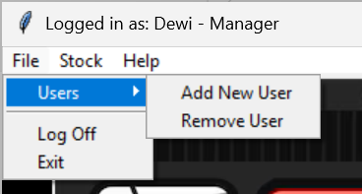

This will open the ‘New Staff Registration’ window. You must enter the new staff user’s first name, last name and a password of their choosing, You must then re-renter the same password as confirmation. Select their ‘position’ from the drop down menu and click ‘Register’ to submit the details.

These are the options available in the ‘position’ drop down menu

All fields must be filled and both passwords must match, one of these messages will indicate if there is such an error.

Upon successful registration this message will appear.

1. REMOVE USER – Selecting ‘Remove User’ will open the ‘Remove Staff Member’ window. This simply asks for the user’s Staff ID only.

After submitting the Staff ID and clicking ‘Remove’, a message will appear asking for confirmation, with the user’s name stated for clarification (in this case - ‘Test’). Click ‘Yes’ to confirm, or no to close the message and Staff Registration window.

If successful, the following message will appear.

1. LOG OFF / EXIT – To switch users, select ‘log off’ in the file menu. This will close the current main page and reopen the login page. Selecting exit will simply close the window whilst automatically logging the current user off.

STOCK

1. SEARCH - All users can use the ‘Search’ and ‘Summary’ function within the stock menu.

Selecting search will open a new search window and allow the user to search for movies by title, genre or director. There is a future extension planned to use one dropdown box and switch between search criteria with a radio button. Currently, there are separate dropdown boxes, using one will clear the others and the results page below. Upon selecting a film, a summary will be shown below along with stock availability.

Above, the movie title, genre and director search results respectively.

1. STOCKLIST SUMMARY – This option is a static page, meaning there is no interaction on the user’s part. It can be useful if a customer asks for advice on various movies (with the console turned to face the customer), or if they would like to see what is available without a particular movie in mind.

1. MODIFY STOCKLIST - For ‘Managers’ and ‘Assistants’ there is a scope for planned future extensions to modify the stocklist through adding and removing films via the interface, as well as changing the rewound status of a returned copy.

Once finalised, the successful messages will look like this (respectively):

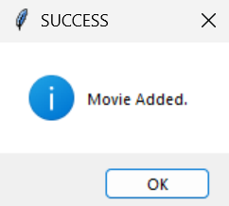

HELP

1. ABOUT – Selecting the ‘About’ option in the Help menu will provide details about the current user, including username, staff ID, the position and appropriate permissions along with the current and most recent login times.

CUSTOMER FUNCTIONS

1. ADD MEMBER – Select this option when a new customer wants to open an account. This is necessary for renting videos, and allows a customer to choose between plans:

‘Standard’ (1 rental at a time for 1 week) or

‘Star’ (2 rental at a time for 2 weeks).

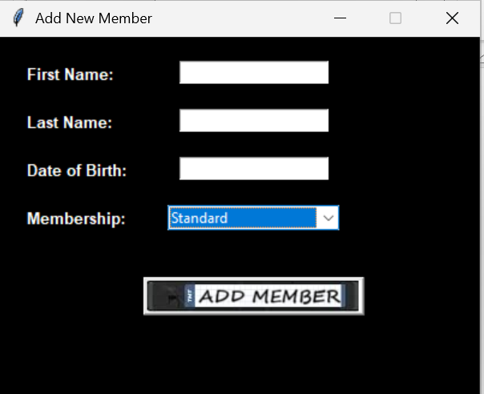

Selecting this option opens a new ‘Add New Member’ window. Input the customer’s details into the labelled boxes, select their desired plan and press ‘Add Member’.

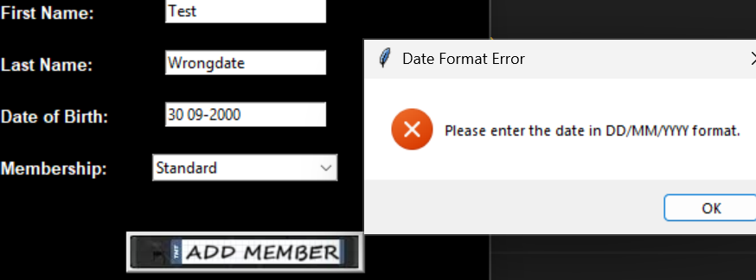

All boxes must be filled and the date of birth must be entered in the correct format, otherwise there will be an error message stating the correct format, then you must click ‘OK’ and re-enter a valid date

Keep in mind that a customer must be over 18 years old to open an account, and a warning message will appear if the date of birth shows they are underage

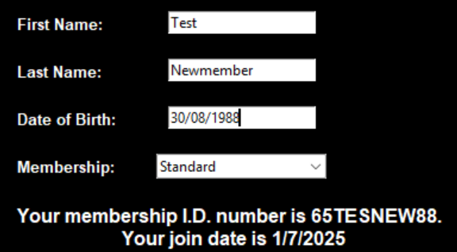

A successful addition will be met with a statement at the bottom of the page indicating the newly created Membership ID (made from two random digits, the first letters of the the first and last names and the two last digits of the date of birth) and the membership date.

1. **RENT –** Select this option to allow a user to rent a video. A new window will appear asking you for the details of the customer and the movie they wish to rent. You must firstly enter the Member ID then select ‘submit user’, as this checks the database for the member’s current account status. If they have unpaid fines over £15, their status is frozen and they must settle their debt before renting another movie.

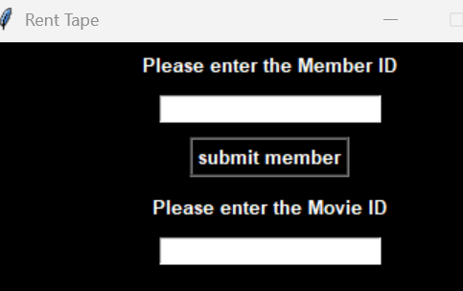

Above, a warning message for a frozen account which must be settled immediately, and a warning message that an account has fines under £15 – they may still rent movies but are advised to settle at their earliest convenience.

With correct details entered, and as long as the account is active and there is still availability, a successful message will appear.

There is a planned extension to add more details to this window and message boxes, regarding due dates, copy availability and the ability to input two movies at a time depending on the membership plan.

1. **RETURN –** Selecting the ‘Return’ option will open a new window used for logging the return of a copy and updating the database in terms of availability and potentially fines. Firstly, the Member ID of the customer returning the tape must be entered.

Entering the Member ID and then clicking ‘Return’ will check the ID against the database for the due date and bring up the appropriate message, as well as imposing fines if needed.

A valid Member ID must be entered, or an error message as seen here will appear.

This would also appear if the ID is valid but the member is not currently renting.

Any tapes currently being rented by the owner of the Member ID will appear in a message alongside the due date.

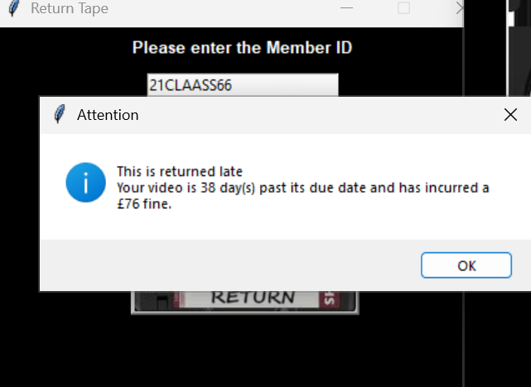

If the tape is returned early, the last message will simply close. However, if a fine has been incurred, another message will appear stating a late return and outlining the cost.

If a member on the ‘Star’ plan is returning two tapes, both of these will be returned in the Member ID search.

This is convenient for returning multiple tapes, however for user convenience there is a planned future extension for returning one copy at a time by offering the option to enter a Copy ID instead of the Member ID, in the case that a customer is renting two tapes but only returning one.

1. **PAY FINES –** Selecting ‘Pay Fines’ will open a new window that would allow the user to enter a member’s ID and then clear the fine upon receipt of payment.

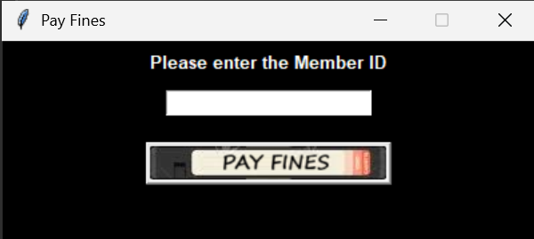

Entering the Member ID above and then clicking ‘Pay Fines’ will search for the customer’s current fine and present it in a message, asking if the fine is paid. The staff user must then take a payment on the till system and then return to the interface to press ‘Yes’ and clear the fine. Selecting ‘No’ will close the window with the fine remaining.

